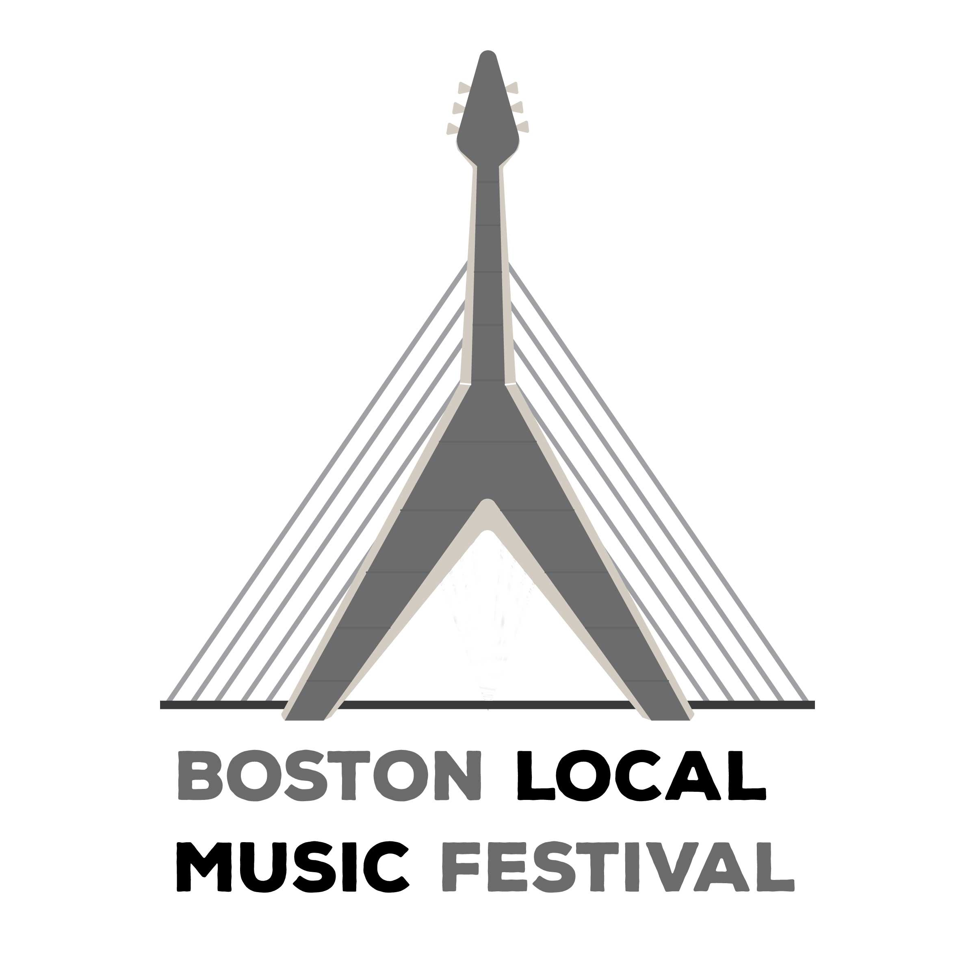

Yes! We wish to support the Boston Local Music Festival as indicated:

___Our Presenting Sponsor……………..……………$25,000 +

Exclusivity

Corporate logo on all printed materials

Corporate logo on stage

Signage/banner opportunities

Status level on printed materials

Corporate logo on event advertisements

Corporate logo on Music Festival homepage and individual corporate page on website through May 2020

Main stage presentations

Main stage mentions

Opportunity to bring corporate/ promotional vehicle

Promotional tent

Opportunity to distribute pre-approved sample items

Mentions and links in our social media campaigns tailored to the needs of your organization

We will customize sponsorship package to you

___ Major Sponsor………..……………………………… $15,000+

Category exclusivity

Corporate logo on all printed materials

Status level on printed materials

Corporate logo on main stage

Corporate logo on event advertisements

Corporate page on Music Festival website through May 2020

Main stage mentions

Promotional tent at Festival

Opportunity to distribute pre-approved sample items

Mentions and links in our social media campaigns

___ Supporting Sponsor………………………………… $7,500+

Corporate logo on printed materials

Status level on printed materials

Corporate logo and ad on Music Festival website through May 2020

Promotional tent at Festival

Opportunity to distribute pre-approved sample items

Mentions and links in our social media campaigns

___ Vendor (Promotional) Booth … (tent not included)

One Day: $2,000

Both Days: $3,500

The Boston Arts Festival is a 501©3

Please fill out our online form at:

TheBostonArtsFestival.com

with the information you’d like printed in our our materials, and please send hi-res logo and print-ready ad artwork jpegs to:
contact@TheBostonArtsFestival.com

Please make check payable to The Boston Arts Festival and mail to:
The Boston Arts Festival
P.O. Box 171080, Boston, MA 02117

